Cypress Installation Guide (macOS)

Prerequisites

1. Install Node[1] and NPM[2]
   1. Go to [Node’s homepage](https://nodejs.org/)
   2. Download the recommended version for macOS  
      Graphical user interface, text, application

      Description automatically generated
   3. Open the downloaded .pkg file
   4. Go through the installation wizard
2. Create a project folder
   1. Open the *Finder* app
   2. Navigate to a place of your choosing, e.g. your Dekstop
   3. Create a new folder for this workshop, e.g. “Itera Cypress Workshop”  
      Graphical user interface, application

      Description automatically generated
3. Open the project folder in your terminal
   1. [Open the *Terminal* app](https://www.muo.com/open-terminal-on-mac/)
   2. Type cd – including the trailing space – and leave it at that
   3. Click-and-drag the project folder, from the *Finder* app, into the *Terminal* app[3]
   4. Press the ENTER/RETURN key
   5. Type pwd and press ENTER/RETURN to verify that your terminal is in the correct folder[4]  
      Text

      Description automatically generated
4. Initialize your project
   1. Type npm init in your terminal[5] and press ENTER/RETURN
   2. You will be prompted to write a name for the project. Type in a URL friendly name, e.g. itera-cypress-workshop, and press ENTER/RETURN
   3. Press ENTER/RETURN without typing anything on the remaining prompts/questions[6]  
      Text

      Description automatically generated
   4. Verify that a package.json file has been created in your project folder. Its content should be the same as the output in your terminal  
      Graphical user interface, application

      Description automatically generated Graphical user interface, text

      Description automatically generated

Installation

1. Type npm install cypress in your terminal[7] and press ENTER/RETURN
2. Verify that the package.json file has been updated with cypress listed as a dependency  
   Text

   Description automatically generated
3. Verify that a node_modules folder has been created in your projected folder  
   Text

   Description automatically generated with medium confidence
4. Congratulations, you’ve now successfully installed Cypress 🎉

**Opening Cypress**

Open up your terminal and navigate to Itera Cypress Workshop and type “npx cypress open”, you should see Cypress loading and the test runner popping up eventually. Now, your project folder should look something like this:

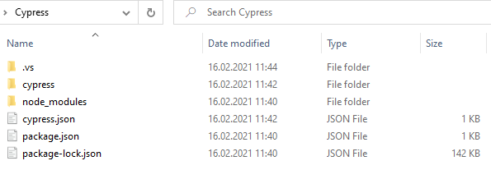

1. Node, or Node.js, allows you to execute JavaScript code on your machine, outside of a browser.
2. NPM is short for *Node Package Manager*. It allows you to install JavaScript applications and libraries, like Cypress.
3. This should add the project folder’s path to the terminal *after* cd .
4. The terminal’s output should match the project folder’s path, e.g. /Users/<username>/Desktop/Itera\ Cypress\ Workshop.
5. Note that the current working directory of your terminal must be the project folder. See step 3.
6. Default values will be used.
7. Note that the current working directory of your terminal must be the project folder. See Prerequisites step 3.